Is this harmful work?

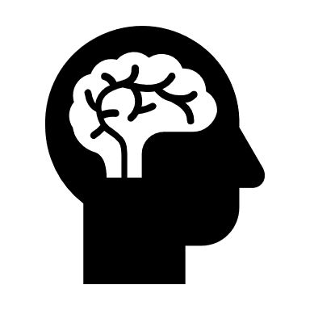

Harmful work is work that can harm…

someone physically someone mentally the environment.

1) Does the image show harmful work? Circle: Yes No | 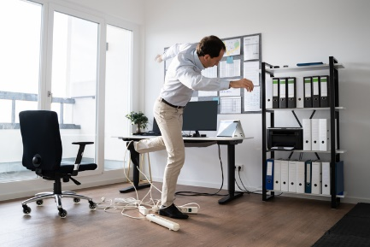  An office worker tripping over wires.
Why do you think that?
I think this shows harmful work because he is tripping over the wires and could injure himself physically. .
How could we make it as safe as possible?
We could make this safer by making sure the wires are placed under the desk. .
2) Does the image show harmful work? Circle: Yes No | 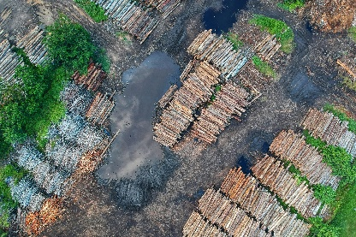  Piles of wood cut down by logging industry.
Why do you think that?
__________________________________________________________________
__________________________________________________________________
__________________________________________________________________
How could we make it as safe as possible?
_______________________________________________________________________________________________
_______________________________________________________________________________________________

3) Does the image show harmful work? Circle: Yes No | 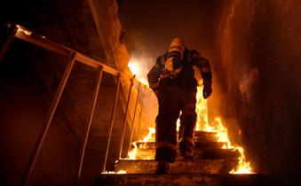Firefighter entering burning building.
Why do you think that?
__________________________________________________________________
__________________________________________________________________
__________________________________________________________________
How could we make it as safe as possible?
_______________________________________________________________________________________________
_______________________________________________________________________________________________
4) Does the image show harmful work? Circle: Yes No | 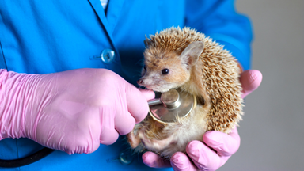Vet checking injured, wild hedgehog.
Why do you think that?
__________________________________________________________________
__________________________________________________________________
__________________________________________________________________
How could we make it as safe as possible?
_______________________________________________________________________________________________
_______________________________________________________________________________________________
5) Does the image show harmful work? Circle: Yes No | 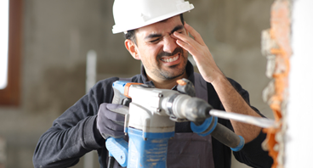  Builder drilling into brickwork.
Why do you think that?
__________________________________________________________________
__________________________________________________________________
__________________________________________________________________
How could we make it as safe as possible?
_______________________________________________________________________________________________
_______________________________________________________________________________________________

6) Does the image show harmful work? Circle: Yes No | 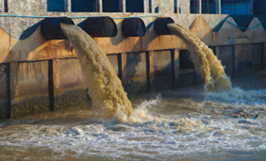  Chemical waste entering the ocean from a factory.
Why do you think that?
__________________________________________________________________
__________________________________________________________________
__________________________________________________________________
How could we make it as safe as possible?
_______________________________________________________________________________________________
_______________________________________________________________________________________________
7) Does the image show harmful work? Circle: Yes No |   Hunched posture and long hours.
Why do you think that?
__________________________________________________________________
__________________________________________________________________
__________________________________________________________________
How could we make it as safe as possible?
_______________________________________________________________________________________________
_______________________________________________________________________________________________
8) Does the image show harmful work? Circle: Yes No | 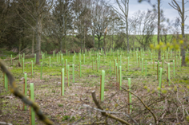  New saplings planted by forestry workers.
Why do you think that?
__________________________________________________________________
__________________________________________________________________
__________________________________________________________________
How could we make it as safe as possible?
_______________________________________________________________________________________________
_______________________________________________________________________________________________

