Being kind
Draw a picture of how Joaquín can be kind to each child.
Matisse has fallen off his bike.
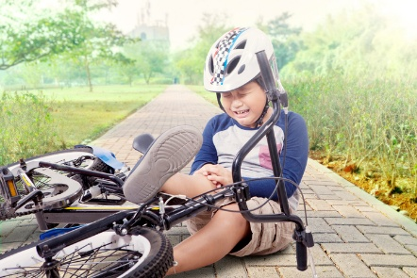

Bethel is feeling sad.

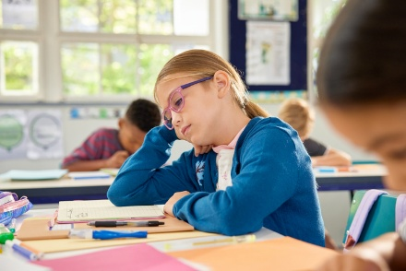


Rafael has just got a new haircut.

