A Horrible Week: Choose Your Own Path
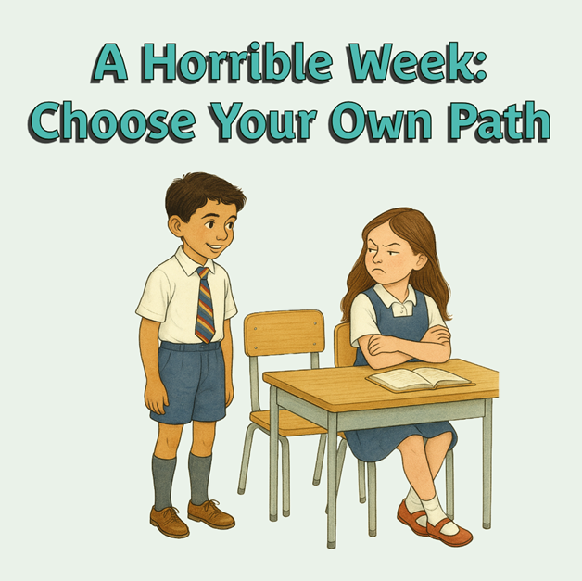

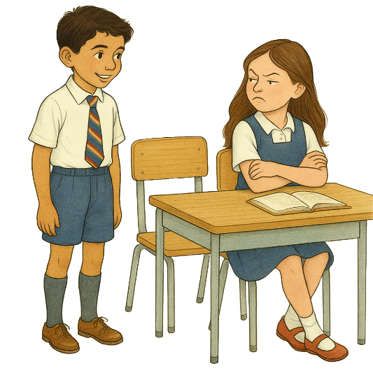
One morning, the teacher had some news. “Everyone’s moving seats today!” he said.
Joaquín felt excited. “I might make a new friend!” he smiled.
The teacher said, “Joaquín, can you move next to Rosa, please?”
Joaquín walked over, sat down and said, “Hi!”
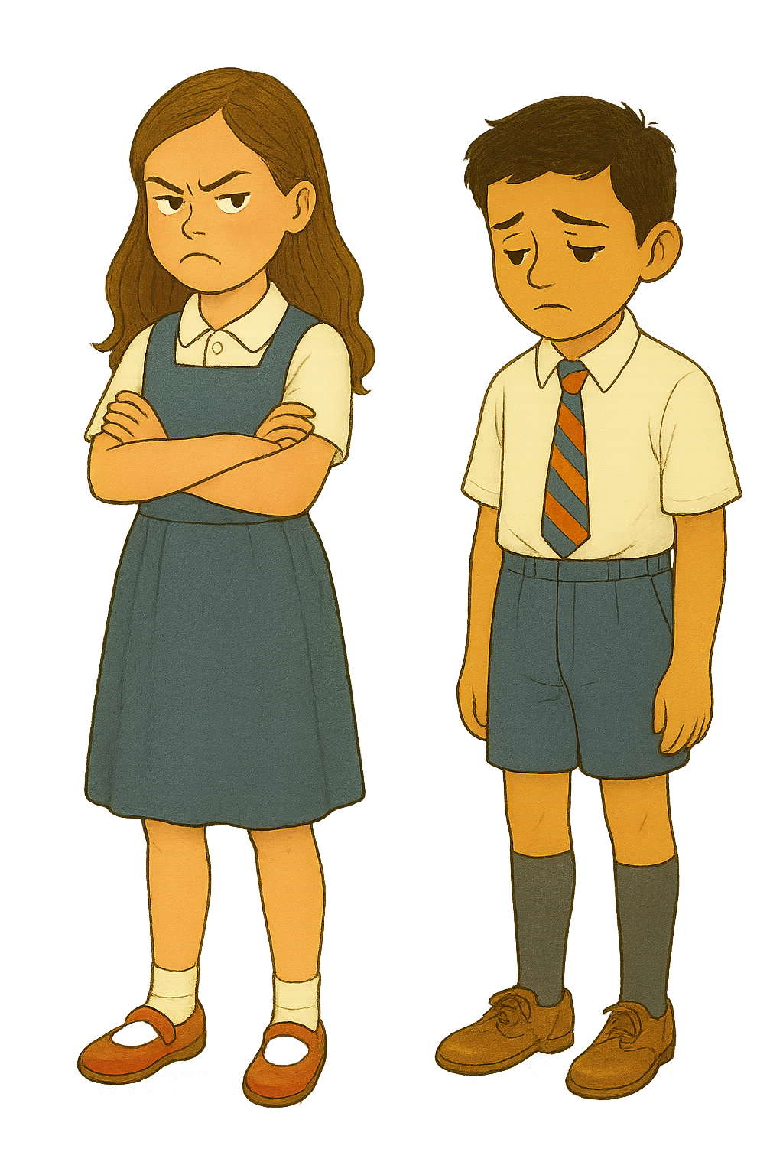
But Rosa pulled a mean face and turned away. Joaquín felt a little sad.
At playtime, Joaquín saw Rosa playing by herself.
He went over and said, “Do you want to play?”
“Go away! I don’t want to play with you!” Rosa snapped.
Now Joaquín felt even sadder.
Maybe Rosa was just having a bad day, he thought. I’ll try again tomorrow.
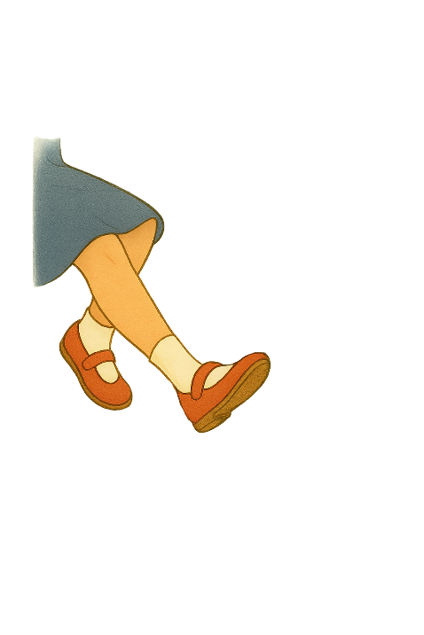
The next day...
Joaquín sat down next to Rosa again. “Hi,” he said kindly.
But Rosa didn’t say anything. She just ignored him. Joaquín felt sad again.
Then, during maths, something hurt his leg. “Ouch!” he thought. “What was that?”
It happened again. It really hurt! He looked down and saw Rosa was kicking him.
“Stop that!” he said. Rosa stopped but stuck her tongue out at him.
Joaquín felt very, very sad. He didn’t understand why Rosa was being so mean.
After school, it was time for swimming, but Joaquín didn’t want to go. He was too upset. He went upstairs and cried. He felt very alone.
The next morning...
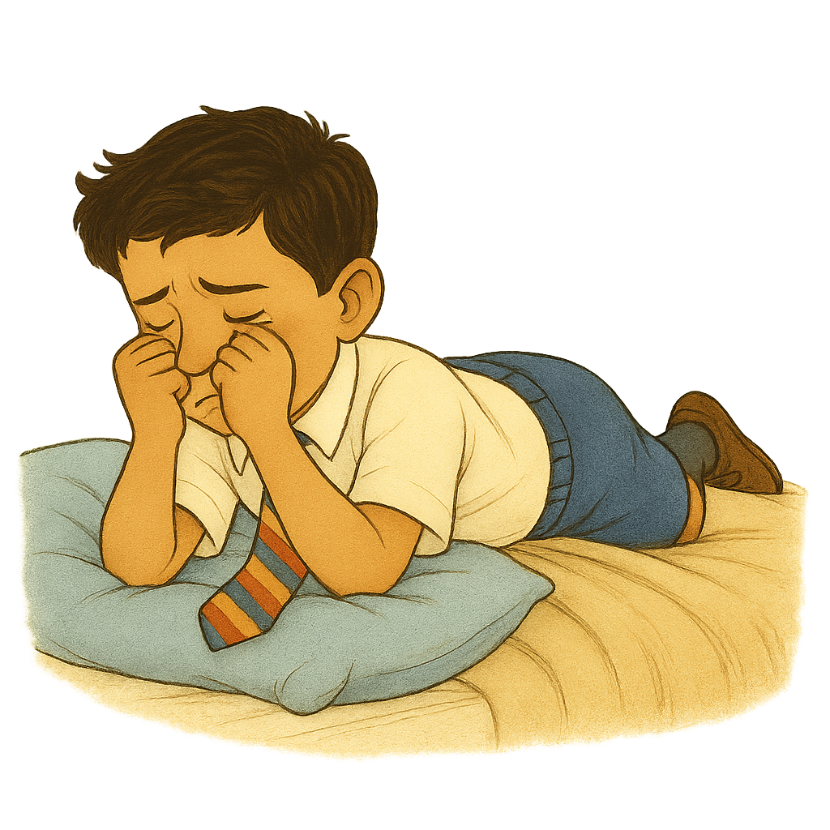
Joaquín didn’t want to go to school. He was scared Rosa would be mean again. He didn’t know what to do.

What should Joaquín do?
- Tell his teacher: Turn to page 3
- Tell his dad: Turn to page 4
- Do nothing: Turn to page 5

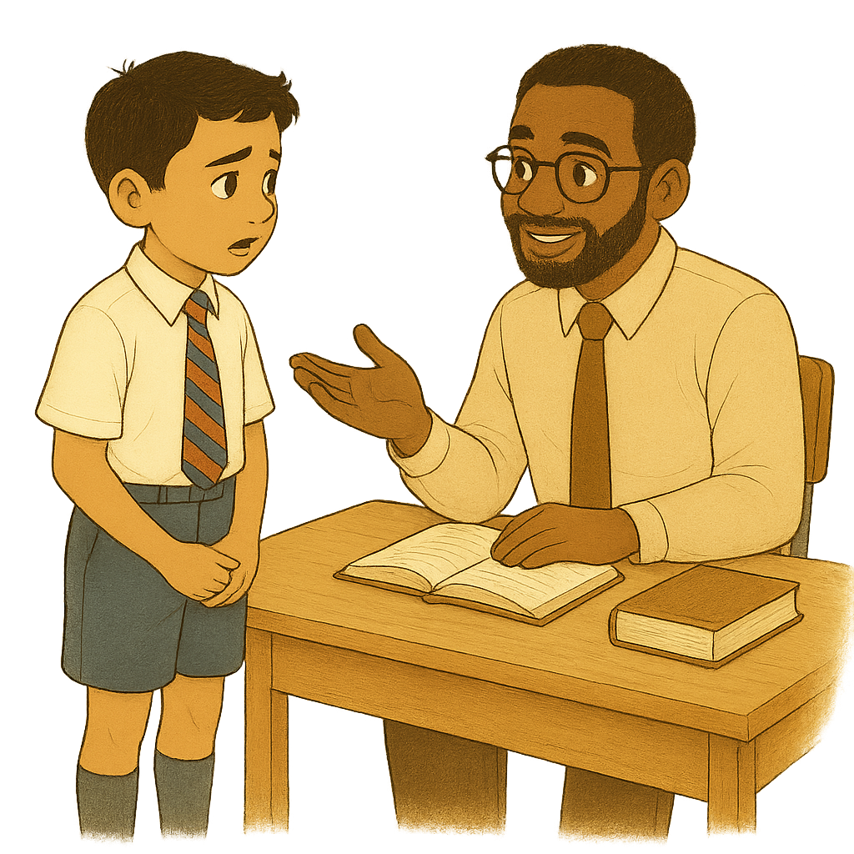
You chose: A. Tell his teacher
Joaquín was brave. He went to tell his teacher what happened.
“I’m so proud of you for telling me. Rosa shouldn’t be treating you like this” the teacher said. “Would you like to move seats?”
Joaquín said yes.
“I’ll talk to Rosa and tell her to stop, and speak to her parents too,” said the teacher. “Please tell me again if anything else happens.”
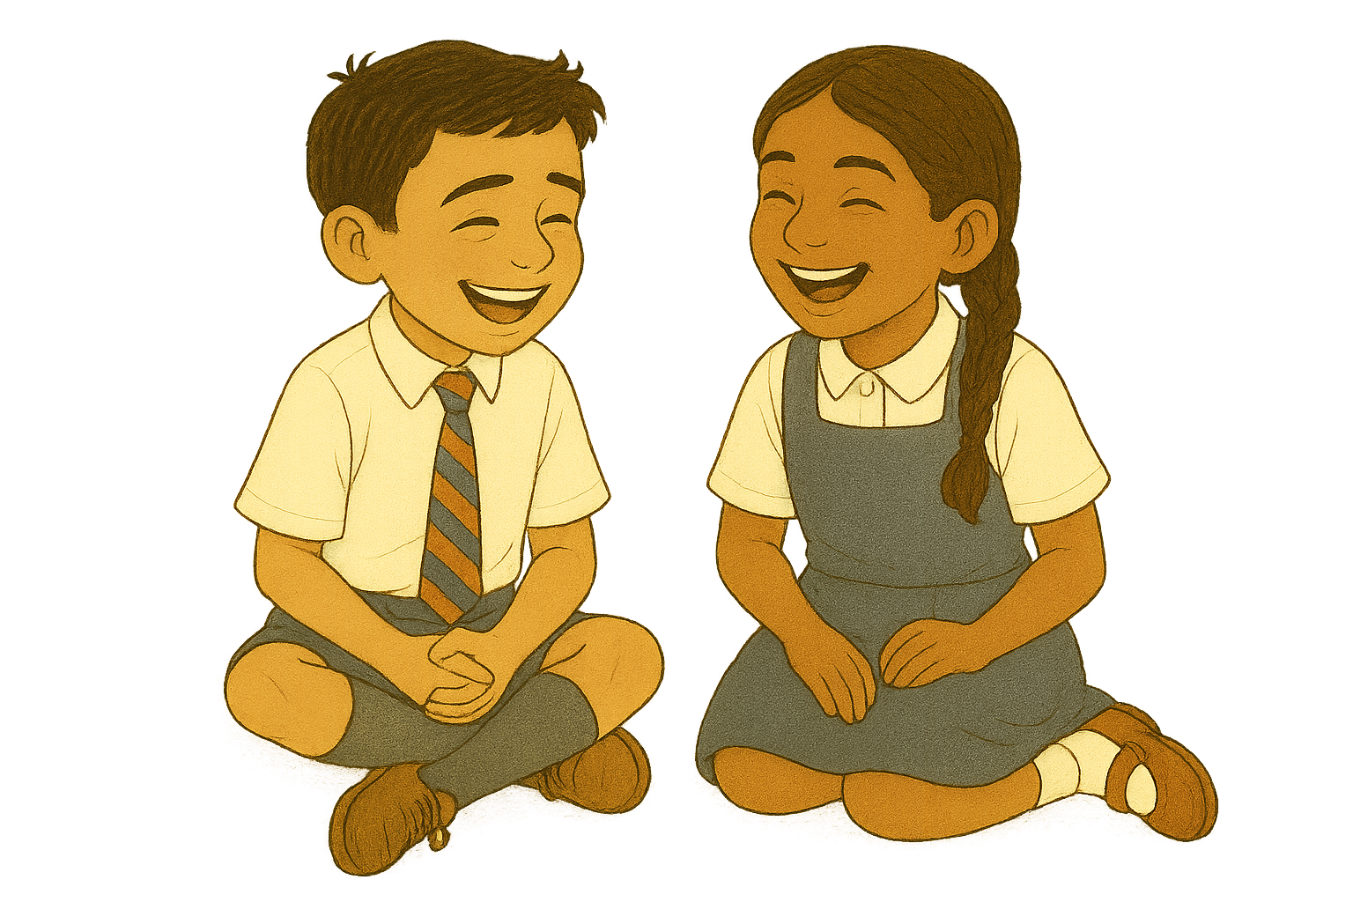
Joaquín moved seats and sat next to a kind girl called Francis. They became good friends.
Rosa didn’t become his friend, but she did stop being unkind.
Joaquín felt much better. He was glad he was brave and told his teacher.

Explore the other endings to the story:
- Tell his teacher: Turn to page 3
- Tell his dad: Turn to page 4
- Do nothing: Turn to page 5

You chose: B. Tell his dad
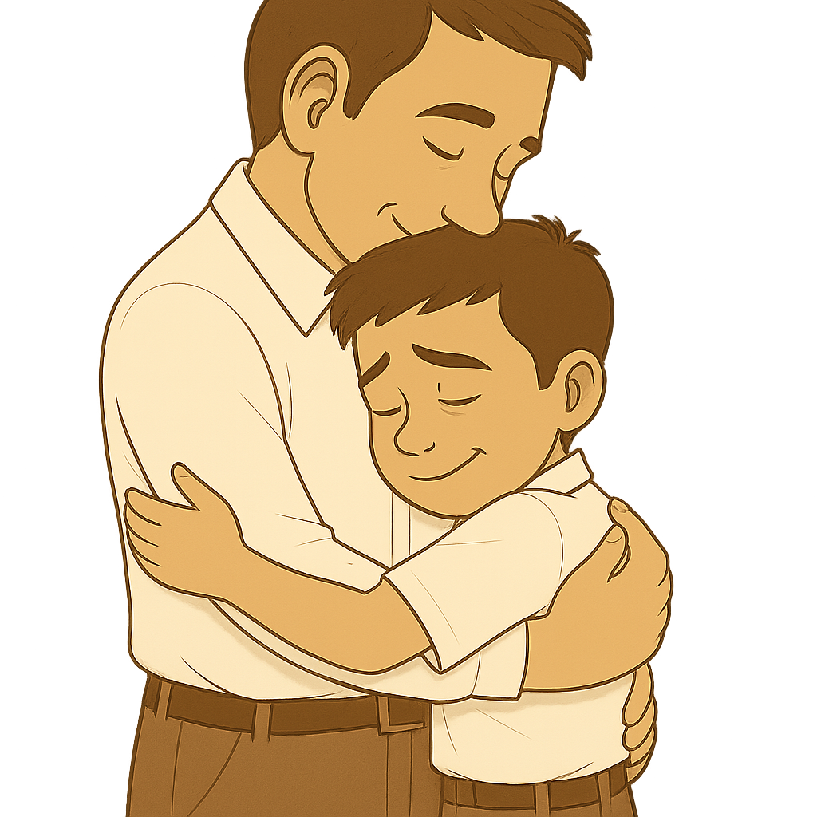
Joaquín told his dad everything that had happened. His dad gave him a big hug.
“It’s OK to feel sad when someone is unkind,” he said. “But we need to make it stop.”
He said he would talk to the teacher at school.
At school, the teacher called Joaquín over.
“I’m really sorry this happened,” he said. “Would you like to move seats?”
Joaquín nodded.
The teacher also said he would speak to Rosa and her parents to help her learn to be kind.
Joaquín moved seats and sat next to a kind girl called Francis. They became good friends.
Rosa never became a good friend, but she stopped being unkind. Joaquín felt much happier again. He was glad he was brave enough to tell his dad.

Explore the other endings to the story:
- Tell his teacher: Turn to page 3
- Tell his dad: Turn to page 4
- Do nothing: Turn to page 5

You chose: C. Do nothing
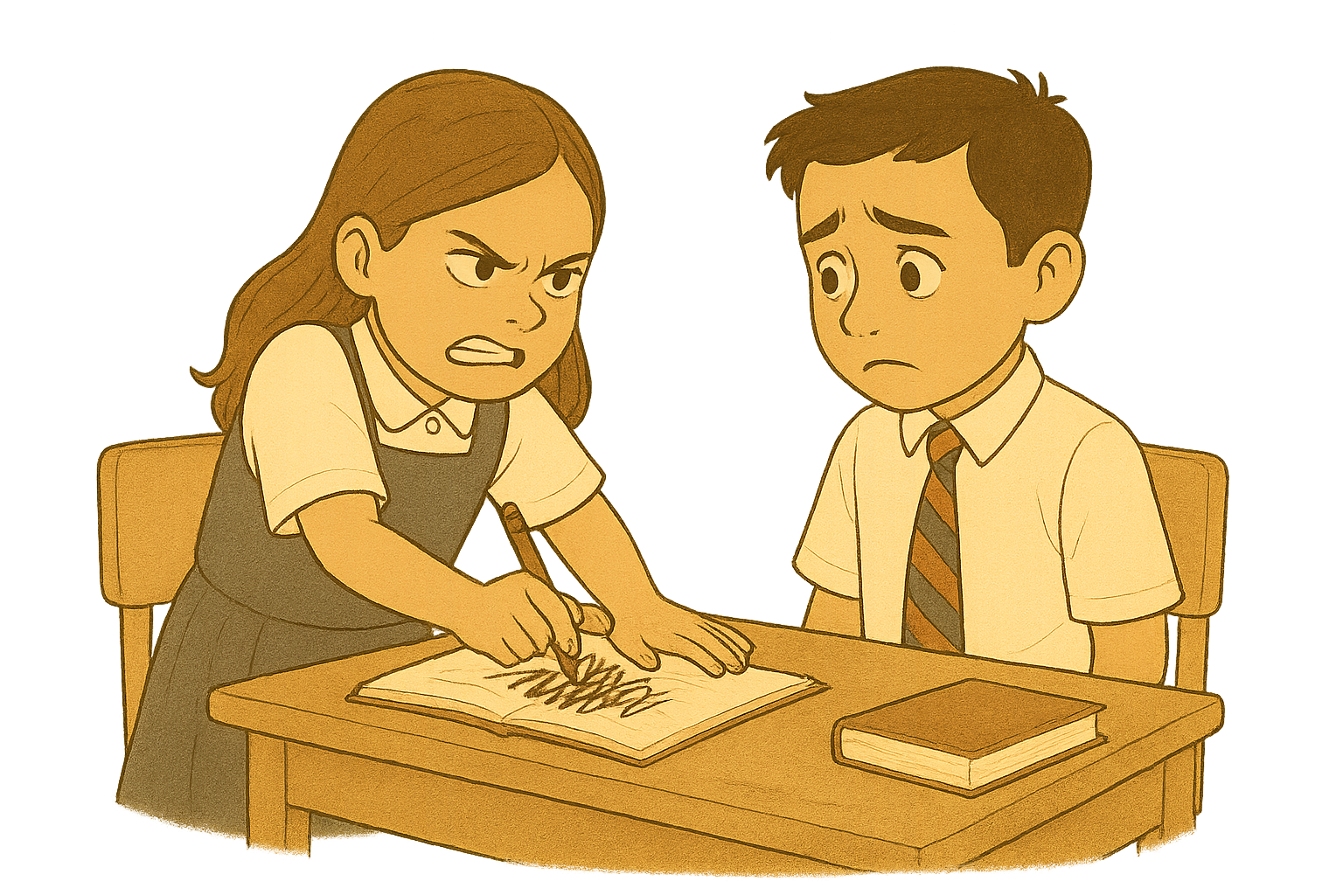
Joaquín didn’t tell anyone. He went to school feeling worried.
Rosa was mean again.
She pushed him in the playground.

She scribbled on his work.

She even called him names.
Joaquín felt so sad. He didn’t want to go to school anymore. He just wanted to stay in his room and cry.

Explore the other endings to the story:
- Tell his teacher: Turn to page 3
- Tell his dad: Turn to page 4
- Do nothing: Turn to page 5

