How are jobs in stories different?
In pairs, talk about how each farming job was different.
Cutting wheat
Peter used ________________________________________________________ to cut wheat.
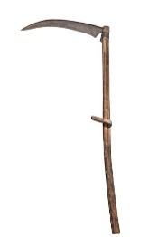
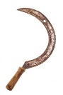
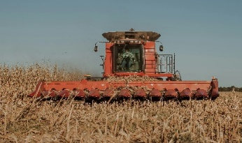
Julia used _________________________________________________________ to cut wheat.

Sickle Scythe Combine Harvester

Picking fruit
Peter used _________________________________________________________ to pick fruit.
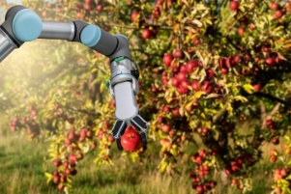
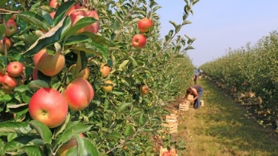
Julia used __________________________________________________________ to pick fruit.

Robotic harvester Hands and baskets

Watering plants
Peter used _____________________________________________________ to water plants.
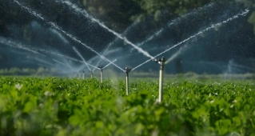
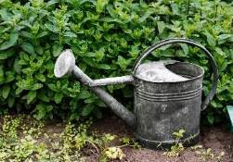
Julia used ______________________________________________________ to water plants.
Irrigation system Watering can

