Placements Journal
Work experience can be exciting and nerve wracking at the same time. This journal will help you to plan your journey so it runs smoothly, and then navigate your way around the work place to ensure you get the most out of the experience.

There are three stages to this journal

Step 1: Preparation is key! Find out your travel time, work wear, and know your safety signs

Step 2: Complete your journal, the mini tasks and interview 2 staff members

Step 3: Reflect on your experience and log the skills you’ve gained

Your work experience journey starts here, good luck!

Placements profile
Reporting:

Who are you reporting to during your work experience?

Dates of experience:

Start date: End date:

Working hours:

From: am/pm To: am/pm daily

Lunchtime arrangements:

Detail below what your lunchtime arrangements will be e.g. packed lunch, lunch provided by employer, buying lunch etc.

Work wear:

Detail below if you are required to wear particular clothing for your role. For example, a suit, high visibility jacket, company clothing etc.

Will this be provided for you?

Travel arrangements:

How will you get to your placement?

How long will this take?

How much will it cost?

Protocols

What do you do if…

You’re ill?

You’re going to be late?

You’re concerned about any aspect of your placement?

Health and safety:

When you start your experience week, you will be informed of any health and safety rules you need to adhere to. You must inform your employer of any medical conditions or health issues you may have, especially if they could affect your ability to undertake certain tasks.

Some safety signs explained:
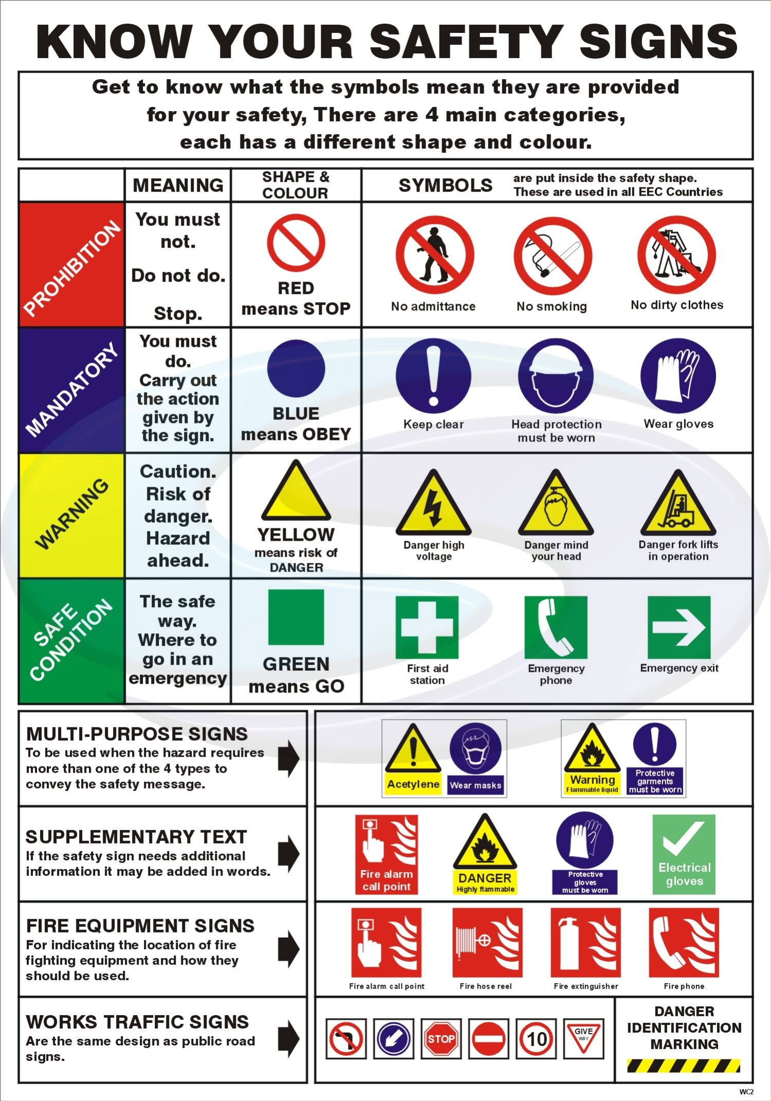

Outcomes from your placement

Overall, what do you hope to achieve?

What skills would you like to gain and improve?

What knowledge you would like to gain?

Who can help you to achieve the above?

First day

Who did you meet?

What was their role?

Who did you work with?

What did you do?

How did you feel?

How do you feel about tomorrow?

If you could change one thing you did today, what would it have been?

Mini tasks

Day 1

Ask a member of staff about their role. Find out one positive about the role, and
one challenging part.

Day 2

Speak to a manager about their role. Find out the top 3 employability skills they would look for in a potential employee.

The top 3 skills are

Day 3

Summarise your day in five words:

Day 4

Think of an area of your role you have found challenging this week. What could you do to tackle this challenge?

One area I have found challenging is

I could tackle this by

Day 5

It’s important to plan the possible steps to get to whatever destination you want to get to.

Using an A4 piece of paper, plan what your pathway might be to get from where you are now in your education and training journey, to one of the roles in the organization where you’re doing work experience. Once you’ve done this, take a photograph and upload it to your Locker on Unifrog.

Summary of week

What was your biggest success of the week?

What did you find challenging?

How did you deal with this challenge?

What skills did you gain from this week?

Log the skills you’ve gained and improved in the Competencies tool on Unifrog – don’t forget to add examples of how you applied that skill to your role!

List 5 job titles of employees within the company:

1:

2:

3:

4:

5:

Interviews with employees

Find two members of staff, employed in different roles, and interview them to find out more about their responsibilities, daily challenges and skills required for that job.

Interview with employee 1

What is your job title?

What responsibilities do you have?

What qualifications does someone need for this job?

Did you have to do any further training for the role?

Does this training lead to qualifications?

How long have you been in this role?

How did you apply for it?

What skills are needed for it?

What is the best part about your role?

What do you find most challenging?

If you were to give one piece of advice to someone looking to get into your industry, what would it be?

Interview with employee 2

What is your role in the company?

How long have you been in this role?

What responsibilities do you have?

Have you been in similar roles previously?

If I were to interview for a job here, what skills would I need?

How should I prepare for an interview?

If you were to give one piece of advice to someone wanting to work in your company, what would it be?

